**Practical 2**

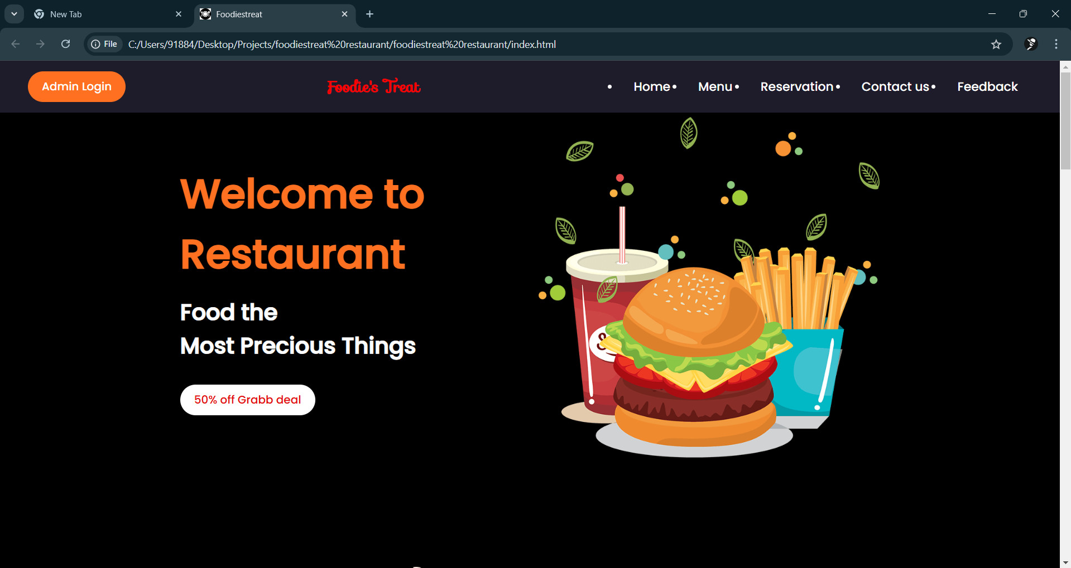

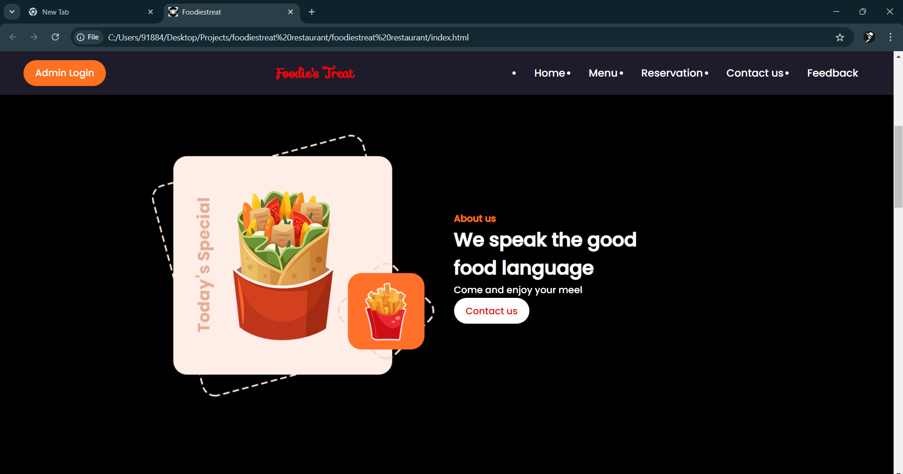

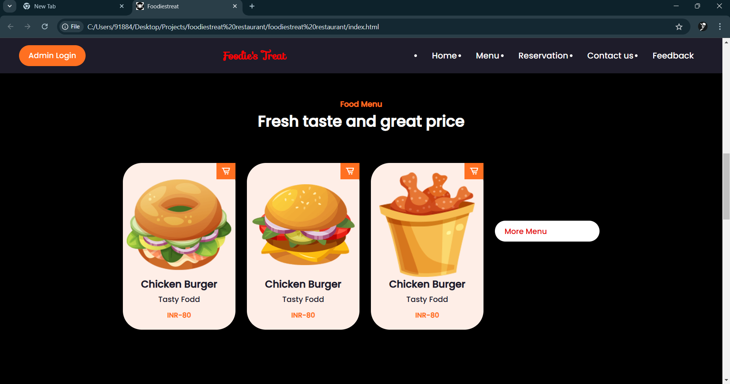

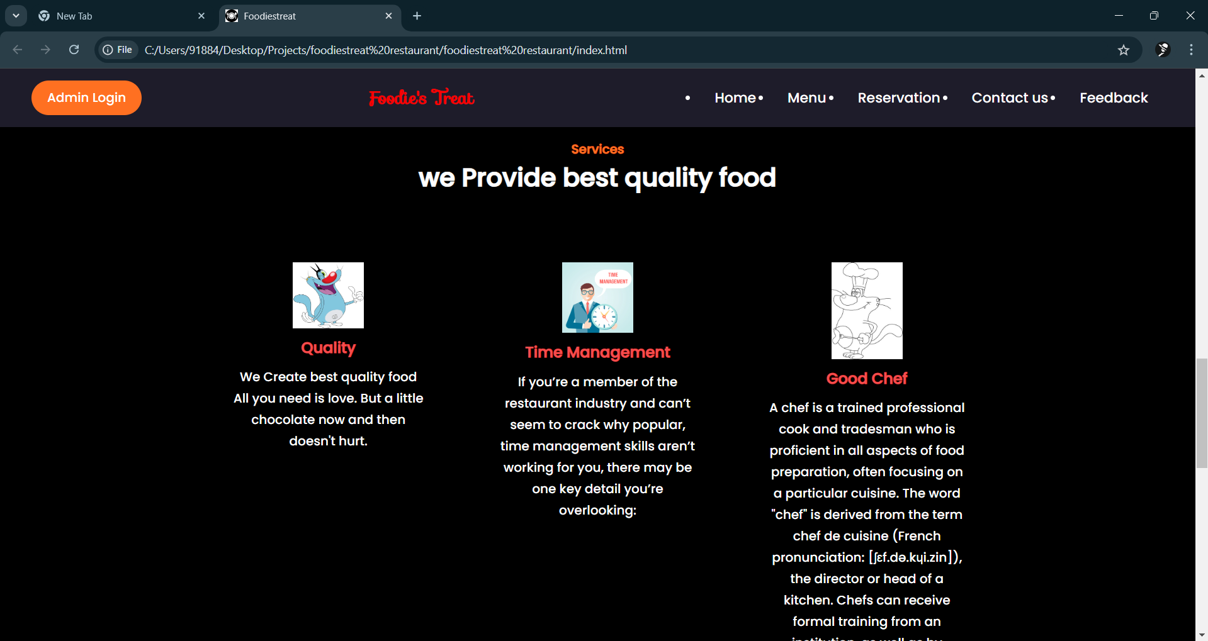

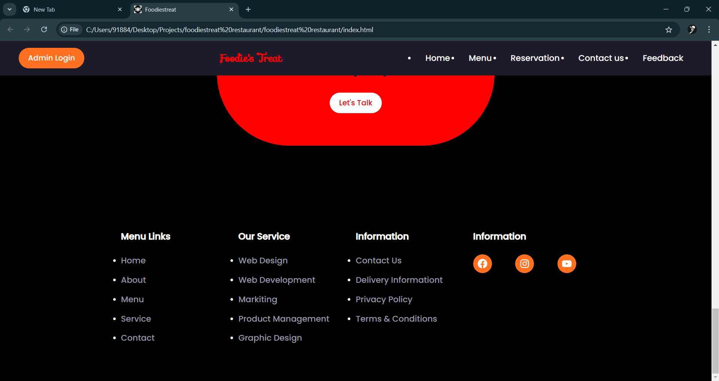

**HTML Code :**

<!DOCTYPE html>

<html lang="en">

<head>

<meta charset="UTF-8">

<meta http-equiv="X-UA-Compatible" content="IE=edge">

<meta name="viewport" content="width=device-width, initial-scale=1.0">

<title>Foodiestreat</title>

<link rel="icon" type="image/x-icon" href="images/restauranticon.jpg">

<link rel="stylesheet" href="css/style.css">

<link rel="stylesheet"

href="https://cdn.jsdelivr.net/npm/boxicons@latest/css/boxicons.min.css">

<!-- or -->

<link rel="stylesheet"

href="https://unpkg.com/boxicons@latest/css/boxicons.min.css">

<link rel="preconnect" href="https://fonts.googleapis.com">

<link rel="preconnect" href="https://fonts.gstatic.com" crossorigin>

<link href="https://fonts.googleapis.com/css2?family=Poppins:wght@500&display=swap" rel="stylesheet">

<link rel="stylesheet" href="https://fonts.googleapis.com/css?family=Sofia">

</head>

<body>

<header>

<a href="admin.html" class="btn1">Admin Login</a>

<a href="#" class="logo">Foodie's Treat</a>

<div class="bx bx-menu" id="menu-icon"></div>

<ul class="navbar">

<li><a href="index.html">Home</a></li>

<li><a href="menu.html">Menu</a></li>

<li><a href="reservation.html">Reservation</a></li>

<li><a href="about us.html">Contact us</a></li>

<li><a href="Feedback2.html">Feedback</a></li>

</ul>

</header>

<!--home start-->

<section class="home" id="home">

<div class="home-text">

<h1>Welcome to Restaurant </h1>

<h2>Food the <br> Most Precious Things</h2>

<a href="" class="btn"> 50% off Grabb deal</a>

</div>

<div class="home-img">

<img src="img/home.png">

</div>

</section>

<!--about start-->

<section class="about" id="about">

<div class="about-img">

<img src="img/about.png">

</div>

<div class="about-text">

<span>About us</span>

<h2>We speak the good <br> food language</h2>

<p>Come and enjoy your meel</p>

<a href="about us.html" class="btn">Contact us</a>

</div>

</section>

<!--about start-->

<section class="menu" id="menu">

<div class="heading">

<span>Food Menu</span>

<h2>Fresh taste and great price</h2>

</div>

<div class="menu-container">

<div class="box">

<div class="box-img">

<img src="img/food1.png" alt="">

</div>

<h2>Chicken Burger </h2>

<h3>Tasty Fodd</h3>

<span>INR-80</span>

<i class='bx bx-cart-alt'></i>

</div>

<div class="box">

<div class="box-img">

<img src="img/food2.png" alt="">

</div>

<h2>Chicken Burger </h2>

<h3>Tasty Fodd</h3>

<span>INR-80</span>

<i class='bx bx-cart-alt'></i>

</div>

<div class="box">

<div class="box-img">

<img src="img/food3.png" alt="">

</div>

<h2>Chicken Burger </h2>

<h3>Tasty Fodd</h3>

<span>INR-80</span>

<i class='bx bx-cart-alt'></i>

</div>

<a href="menu.html" class="btn">More Menu</a>

</div>

</section>

<!--Servie start-->

<section class="services" id="services">

<div class="heading">

<span>Services</span>

<h2>we Provide best quality food</h2>

</div>

<div class="service-container">

<div class="s-box">

<img src="chef/quality.jpg" alt="">

<h3>Quality</h3>

<p>We Create best quality food <br>All you need is love. But a little chocolate now and then doesn't hurt.</p>

</div>

<div class="s-box">

<img src="chef/time-management.jpg" alt="">

<h3>Time Management</h3>

<p>If you’re a member of the restaurant industry and can’t seem to crack why popular, time management skills aren’t working for you, there may be one key detail you’re overlooking:</p>

</div>

<div class="s-box">

<img src="chef/chef.jpeg" alt="">

<h3>Good Chef</h3>

<p>A chef is a trained professional cook and tradesman who is proficient in all aspects of food preparation, often focusing on a particular cuisine. The word "chef" is derived from the term chef de cuisine (French pronunciation: [ʃɛf.də.kɥi.zin]), the director or head of a kitchen. Chefs can receive formal training from an institution, as well as by apprenticing with an experienced chef.</p>

</div>

</div>

</section>

<!--call to action-->

<section class="cat">

<h2>We make quality food <br> Everyday</h2>

<a href="contactform.html" class="btn">Let's Talk</a>

</section>

<!--footer start-->

<section id="contact">

<div class="footer">

<div class="main">

<div class="col">

<h4>Menu Links</h4>

<ul>

<li><a href="#">Home</a></li>

<li><a href="#">About</a></li>

<li><a href="#">Menu</a></li>

<li><a href="#">Service</a></li>

<li><a href="#">Contact</a></li>

</ul>

</div>

<div class="col">

<h4>Our Service</h4>

<ul>

<li><a href="#">Web Design</a></li>

<li><a href="#">Web Development</a></li>

<li><a href="#">Markiting</a></li>

<li><a href="#">Product Management</a></li>

<li><a href="#">Graphic Design</a></li>

</ul>

</div>

<div class="col">

<h4>Information</h4>

<ul>

<li><a href="about us.html">Contact us</a></li>

<li><a href="#">Delivery Informationt</a></li>

<li><a href="#">Privacy Policy</a></li>

<li><a href="#">Terms & Conditions</a></li>

</ul>

</div>

<div class="col">

<h4>Information</h4>

<div class="social">

<a href="#"><i class='bx bxl-facebook-circle'></i></a>

<a href="https://www.instagram.com/navin1255n/"><i class='bx bxl-instagram'></i></i></a>

<a href="https://www.youtube.com/@darky_shadow8707"><i class='bx bxl-youtube' ></i></a>

</div>

</div>

</div>

</div>

</section>

</body>

</html>

**CSS Code :**

*{

    padding: 0;

    margin: 0;

    box-sizing: border-box;

    font-family:'Poppins' , sans-serif ;

    scroll-behavior: none;

    text-decoration: none;

}

:root{

    --main-color:#ff7021;

    --text-color:#fff;

    --bg-color:#1e1c2a;

    --big-font:5rem;

    --h2-font:2.25rem;

    --p-font:0.9rem;

}

*::selection{

    background: var(--main-color);

    color:#fff

}

body{

    color: var(--text-color);

    background: black;

}

header{

    position: fixed;

    top: 0;

    right: 0;

    width: 100%;

    z-index: 1000;

    display: flex;

    align-items: center;

    justify-content: space-between;

    padding: 30px 170px;

    background:var(--bg-color) ;

}

.logo{

    color: red;

    font-weight: 600;

    font-size: 1.4rem;

    font-family: "Sofia", sans-serif;

}

.navbar{

    display: flex;

}

.navbar a{

    color: var(--text-color);

    font-size: 1.1rem;

    padding: 10px 20px;

    font-weight: 500;

}

.navbar a:hover{

    color:var(--main-color);

    transition: .4s;

}

#menu-icon{

    font-size: 2rem;

    cursor:pointer;

    display: none;

}

section{

    padding: 70px 17%;

}

.home{

    width: 100%;

    min-height: 90vh;

    display: grid;

    grid-template-columns: repeat(2,1fr);

    grid-gap:1.5rem;

    align-items: center;

}

.home-img img{

    max-width: 100%;

    width: 600px;

    height: auto;

}

.home-text h1{

    color: var(--main-color);

    font-size: 58px;

}

.home-text h2{

    font-size: var(--h2-font);

    margin: 1rem 0 2rem;

}

.btn1{

    display: inline-block;

    padding: 10px 20px;

    background: var(--main-color);

    color: #fff;

    border-radius: 40px;

}

.btn1:hover{

    transform: scale(1.2) translateY(10px);

    transition: .4s;

}

.btn{

    display: inline-block;

    padding: 10px 20px;

    background: white;

    color: #e40f0f;

    border-radius: 40px;

}

.btn:hover{

    transform: scale(1.2) translateY(10px);

    transition: .4s;

}

.about{

    display: grid;

    grid-template-columns: repeat(2,2fr);

    grid-gap: 1.5rem;

    align-items: center;

}

.about-img img{

    max-width: 100%;

    width: 480px;

    height: auto;

}

.about-text span{

color: var(--main-color);

font-weight: 600;

}

.about-text h2{

    font-size: var(--h2-font);

}

.about-text p{

    margin: 0.8 rem 0 1.8rem;

    line-height: 1.7;

}

.heading{

    text-align: center;

}

.heading span{

    color: var(--main-color);

    font-weight: 600;

}

.heading h2{

    font-size: var(--h2-font);

}

.menu-container{

    display: grid;

    grid-template-columns: repeat(auto-fit, minmax(220px, auto));

    grid-gap: 1.5rem;

    align-items: center;

}

.box{

    position: relative;

    margin-top: 4rem;

    height: auto;

    display:flex;

    flex-direction: column;

    align-items: center;

    justify-content:center;

    background:#feeee7;

    padding: 20px;

    border-radius: 40px;

}

.box-img{

    width: 220px;

    height: 220px;

}

.box-img img{

    width: 100%;

    height: 100%;

}

.box h2{

    font-size: 1.3rem;

    color: var(--bg-color);

}

.box h3{

    color: var(--bg-color);

    font-size: 1rem ;

    font-weight: 400;

    margin: 4px 0 10px;

}

.box span{

    font-size: var(--p-font);

    color: var(--main-color);

    font-weight: 600;

}

.box .bx{

    background: var(--main-color);

    position: absolute;

    right: 0;

    top: 0;

    font-size: 20px;

    padding: 7px 10px;

    border-radius: 0 0.5rem 0 0.5;

}

.service-container{

display: grid;

grid-template-columns: repeat(auto-fit,minmax(240px, auto));

grid-gap: 1.5rem;

margin-top: 4rem;

}

.s-box{

    text-align: center;

    padding: 20px 30px;

}

.s-box img{

    width: 90px;

}

.s-box h3{

    margin: 4px 0 10px;

    color: rgb(245, 76, 76);

    font-size:1.2rem ;

}

.s-box p{

    line-height: 1.7;

}

.cat {

    background: red;

    padding: 70px 0;

    text-align: center;

    width: 39%;

    margin: 100px auto;

    border-radius: 155px;

}

.cat h2{

    font-size: 2rem;

    color:var(--bg-color);

    margin-bottom: 30px;

}

/*Footer*/

.main{

    display: flex;

    flex-wrap: wrap;

}

.footer{

    padding: 10px 0;

}

.col{

    width: 25%;

}

.col h4{

    font-size: 1.2rem;

    color: var(--text-color);

    margin-bottom: 25px;

    position: relative;

}

.col h4::before{

    position: absolute;

    height: 2px;

    width: 50px;

    left: 0;

    bottom: -8px;

    background: var(--main-color);

}

.col ul li:not(:last-child){

    margin-bottom: 15px;

}

.col ul li a{

    color: #9897a9;

    font-size: 1.1rem;

    display: block;

    text-transform:capitalize ;

    transition: .4s;

}

.col ul li a:hover{

    color: var(--text-color);

    transform: translateX(-12px);

}

.col .social{

    width: 220px;

    display: flex;

    align-items: center;

    justify-content: space-between;

}

.col .social a{

    height: 40px;

    width: 40px;

    background: var(--main-color);

    color: var(--text-color);

    display: inline-flex;

    align-items: center;

    justify-content: center;

    font-size: 1.5rem;

    border-radius: 50px;

    transition: .4s;

}

.col .social a:hover{

    transform: scale(1.2);

    color:var(--bg-color);

    background: var(--text-color);

}

@media (max-width:1560px){

    header{

        padding: 15px 40px;

    }

    :root {

        --big-font:3.5rem;

        --h2-font:2rem;

    }

}

@media (max-width:1140px){

    section{

        padding: 50px 8%;

    }

    #menu-icon{

        display: initial;

        color: var(--text-color);

    }

    header .navbar{

        position:absolute;

        top: -400px;

        left: 0;

        right: 0;

        display: flex;

        flex-direction: column;

        text-align: center;

        background: #2b2640;

        transition: .3s;

    }

    header .navbar.active{

        top: 70px;

    }

    .navbar a{

        padding: 1.5rem;

        display: block;

    }

    .col{

        width: 50%;

        margin-bottom: 10px;

    }

}

@media (max-width: 720px){

    header{

        padding: 10px 16px;

    }

    .home{

        grid-template-columns:1fr ;

        text-align: center;

    }

    .about{

        grid-template-columns: 1fr;

        text-align: center;

    }

    .about-img{

        order:2 ;

    }

    section{

        padding: 100px 7%;

    }

}

@media (max-width:575px){

    .col{

        width: 100%;

    }

}